PROJECT PLANNING PHASE

Date | 2 November 2025
Team ID | NM2025TMlD03628
Project name | Laptop Request Catalog Item

Purpose of the Planning Phase:

The purpose of the planning phase in the Laptop Request Catalog Item project using ServiceNow is to clearly define how the project will be executed, managed, and delivered successfully.
• Define project goals and scope
• Understand requirements

Project Overview :

The Laptop Request Catalog Item using ServiceNow project aims to develop an automated and user-friendly system that enables employees to request laptops easily through the ServiceNow platform. This catalog item will streamline the entire process—from request submission to approval and fulfillment—eliminating manual work and delays.ProjectGoals:

• Automate the Laptop Request Process
• Replace manual request methods with an online, automated system through the ServiceNow platform.
• Simplify User Experience
• Make it easy for employees to request laptops using a simple and user-friendly catalog form.

Project Deliverables:
• Requirement Specification Document
A document that outlines all functional and non-functional requirements for the laptop request catalog item.
• Workflow Design
A planned workflow illustrating the process steps—from request submission and approval to fulfillment and closure.
• Service Catalog Item Design
A prototype or draft design of the laptop request catalog item, including form fields, request types, and categories.

Team Roles and Responsibilities:
• Plan, coordinate, and monitor all project activities.
• Manage the timeline, budget, and resources.
• Communicate with stakeholders and ensure project goals are met.
• Design and develop the Laptop Request Catalog Item.
• Configure workflows, approvals, and notifications in ServiceNow.
• Integrate with Asset Management if required.

Resources Needed:
Platform: ServiceNow Developer Instance
Tools: Flow Designer, Tables, and Dashboard modules
Hardware: Laptop or desktop with internet access
Software: Any web browser (e.g., Chrome, Edge)
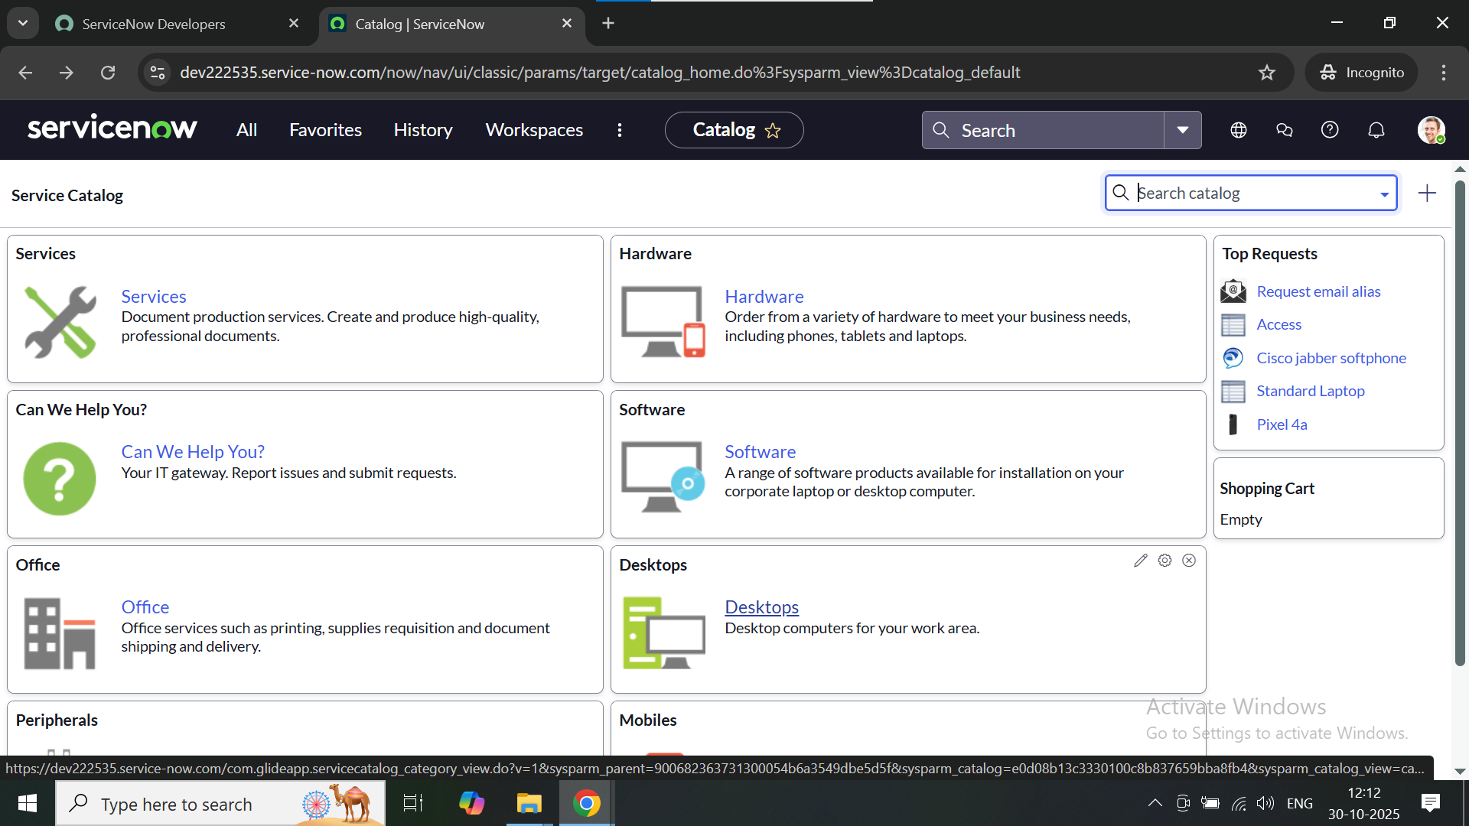

Conclusion:
The project planning phase for the Laptop Request Catalog Item using ServiceNow plays a crucial role in laying a strong foundation for successful implementation. Through careful planning, the project goals, scope, requirements, resources, and timelines are clearly defined. This ensures that all team members understand their roles, responsibilities, and potential risks.

